

**2016**

**Race Briefing**

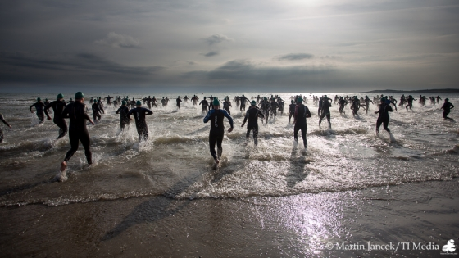





**Hell of the West**

**Olympic Distance Triathlon**

**25 th June 2016**

**PREPARED BY:**

**Mark Kennedy, Race Director**

RMATIN

**COURSE INFORMATION PACK**



The 32nd annual Hell of the West Triathlon takes place on Saturday 25th June 2016.

Race headquarters is in KIlkee, Co. Clare in the Kilkee Bay Hotel.

Kilkee is located in the scenic west coast of County Clare. It is approximately a 45 minute drive from Ennis travelling on the N68. Kilkee is just beyond mid-way between the world famous Cliffs of Moher and the unspoilt beauty of Loop Head on the N67 coastal route.

If you are coming from County Kerry, the Shannon Ferry is perfectly located, connecting Tarbert in North Kerry to Killimer just 15 minutes from Kilkee.

Kilkee Tourist Office

(Summer Only)

O'Connell Street

Kilkee

Tel: 065-9056



**Saturday June 27th 2009**

**1.5 km Swim 45 km Cycle 10km Run**

**REGISTRATION**

**MAP**

**CAR PARKING**

All entrants are requested to work with the organizers on parking. We are respectfully asking you to be considerate of other competitors, and especially the local community who are giving us great support. There is public car parking at the dive centre (North) end of the beach. This is metered parking with a modest charge for the day. We are advised by Clare County Council that Traffic Wardens will be strict on stray parking in the town and beach area on the day– You have been warned. Please note that strictly NO PARKING will be permitted in the bandstand area or Strand Road from transition to Waterworld Cross roads. There is no parking in the triangle in front of the bandstand as this is a medical area for access and egress of medical and safety vehicles.

**REGISTRATION**

6.00pm to 10pm on Friday 24th and 7am to 8am on Saturday 25th .

Registrations for both individuals and relays will take place at the Race HQ at the Kilkee Bay Hotel on left hand side on entrance road to Kilkee, on Friday evening from 6.00pm to 10.00pm or on Saturday morning from 7am to 8am. Please make every effort to complete your registration on the Friday night. Registration must close sharply at 8am on Saturday morning. If you arrive to the hotel after 8.45am we are not guaranteeing your registration. No registration = No race!

Please have your TI identification card or your 1 day Triathlon Ireland License to hand.

For relays – PLEASE NOTE: Relay teams are asked to register together if possible, there must be at least one TI licensed athlete on the team.

All entrants will receive a timing chip, a swim hat (wave specific), a race number, and a very generous goodie bag with many surprises for all.

In case of emergency, please write any medical conditions you have on the back of your race number. Do not fold or cut your race number.

A number of sports shops will also be at registration so you can pick up anything that you have forgotten in terms of tri equipment, swimwear and energy bars etc. Wheelworx and The HUBB will be providing a bike service on the Saturday morning at the beach area from 8am. They will have bike parts available for those bits you have forgotten or broken on the warm ups. They will do manual checks of gears etc before your race. They cannot perform major surgery on your bikes – it is your responsibility to ensure your bike is in roadworthy condition before you race.



**Saturday June 27th 2009**

**1.5 km Swim 45 km Cycle 10km Run**

**TRANSITION & BRIEFING**

**BIKE RACKING AND TRANSITION SET UP:**

Bandstand Kilkee Beach open from 7.30 am. Please note that only registered entrants may enter the Transition area. You MUST have your bike and equipment set up prior to the race briefing. Transition will be enclosed by crowd control barriers. There will be a **security, mechanical and helmet check** at the transition area entrance. Your bike number must correspond to your race entry. All bikes and helmets will be checked on entry to transition from a safety point of view – any unworthy equipment will be refused entry. There will be helmets on sale and a bike service available in the bandstand area but please ensure you check your equipment well in advance of the race – we obviously cannot allow any competitor onto the roads with faulty bikes or without a helmet. All athletes must place their equipment only at their location of their bike in a neat and tidy fashion. Any athlete discarding equipment outside their personal space in transition will be penalised. This is to include wet suits, bike, runners, bike shoes, goggles, hats etc. Transitionwill be open for set up from 7.30am to 8.30am. It is your responsibility to be prepared to attend Race briefing for 9 am sharp.

**ALL ENTRANTS MUST ATTEND THE RACE BRIEFING BEFORE RACING:**

The Race Briefing is an important safety measure for our event and is COMPULSORY for all race entrants. Any last minute changes to the course will be announced at this time and we will inform you of any safety issues that may affect your race. This brief will be the latest information at hand to the event organizers and race referee – it will not suffice to have read the race brief.

The Race BRIEFING will commence at **9 am** at transition in front of bandstand.

**RACE STARTING POINT:**

Once the briefing has concluded entrants will be led to the STARTING POINT which is on the right hand side of the beach as per swim map (next page).

Please note that In the event of adverse weather on the day, and if either the Race Referee or Water Safety Officer determine that neither of the routes outlined above is safe to swim then the swim will be abandoned and replaced with an 5km run using the Dunlicky road traditional route.

**Relays,** please note that your transition area is separate from the individual entrants transition area. There will be no access to the recovery area until the first individual racers finish. The bag drop is for individual racers only.

**Please note there is a high tide at Race start times.** All swimmers are to access the beach through transition and are to step over the timing mats. Make your way once called to the North end of the beach onto the raised platform as directed. Your wave will be called prudently, please follow all the race starters’ instructions for a safe swim start.



**Saturday June 27th 2009**

**1.5 km Swim 45 km Cycle 10km Run**

**SWIM COURSE**

**IN**

* Race Swim Caps (Silicon) will be provided to all entries. - 5 different colour hats for each start: All swimmers must wear the race hat provided. Additional hats may be worn underneath the race provided hat.
* Wetsuits are mandatory for all swimmers taking part including all relay swimmers. Anyone not wearing a suitable wetsuit will not be permitted to enter the water/race.
* **All swimmers numbers will be recorded (via timing chip mat)as they exit the transition onto the beach via the beach exit of transition area. Under no circumstances is any swimmer permitted to leave the bandstand before their number is recorded and or enter the beach other than through transition. This is to ensure that all swimmers are safe.**
* There will be 5 swim starts, at 9.30 am and thereafter, with the last wave at 9.50.
* Canoes and personal motorized craft will flank the swim in an effort to keep swimmers on course.
* Only very strong swimmers should go to the front of the swim start. Leave your ego behind! Weaker swimmers are well advised to start at the sides and stay to the rear of the field. You will gain nothing by placing yourself at the front of the swim and will find yourself being ploughed over by stronger swimmers. This could potentially finish your race through injury or discomfort. Worse still you could get into difficulty or cause somebody else to get into difficulty.
* There will be 6 large marker buoys 2 metres high anchored in the bay (Keep all buoys on your left at all times). Swim will start at waters edge on the RIGHT hand side of the bay the way along the beach towards the pier to the right of the transition area.
* There will be rescue boats with lifeguards on board, rescue divers and canoes in the water monitoring the swimmers.
* Anyone cutting corners/buoys will be immediately disqualified and taken out of the water by the rescue boats and not permitted to continue. Kayakers will be monitoring each buoy to ensure this.
* If a swimmer wishes to retire from the swim for any reason, roll over on your back and raise your clenched fist in the air, stay calm, and a rescue boat will come to your assistance.
* There is a 1.05 hr time limit on the swim or if a marshal feels you are endangering yourself or others you can be withdrawn from the swim. Anyone removed from the water will not be permitted to continue the race and must hand in their timing chip and numbers immediately to a race marshal once they arrive back to shore.
* **Our main priority in the water is safety! We know you want to challenge yourself but the water is not the place for aggressive behaviour and we will not accept safety breaches**

**The water marshals decision is final!**

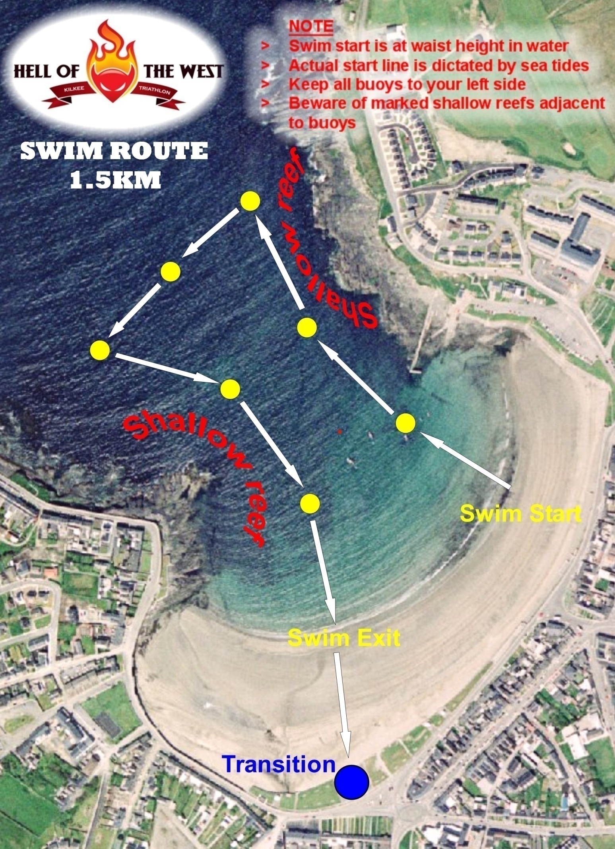



**Saturday June 27th 2009**

**1.5 km Swim 45 km Cycle 10km Run**

**TRANSITION 1**

* Exit the water and run up the beach towards the Transition area and enter only at the sanctioned point.
* Race number must be worn on the back during the cycle. Numbers must be clearly visible at all times. Anyone not correcting their number after being advised by marshals to do so, will be penalised 2 minutes for number violations.
* For safety and Insurance reasons - Personal Stereos/IPODs etc are not allowed on the course of the race. Anyone wearing any such device during the course will be immediately disqualified from the race.
* You must put on your helmet and fasten it before removing your bike from the bike rack. Anyone, who has an unfastened helmet while in contact with their bike will be asked to stop and refasten their helmet, failing to do so will result in a 2 minute time penalty.
* Exit through the timing mat to ensure your times are recorded.
* Walk your bike to the path and onto the road before mounting your bike.
* People may leave spare wheels in transition at the allocated spare wheel spot, but must be numbered with your race number and such wheels are not to be used by other competitors. Breach of these rules will result in disqualification of both athletes involved. The race organisers are not responsible for the security of any such equipment.



**Saturday June 27th 2009**

**1.5 km Swim 45 km Cycle 10km Run**

**CYCLE ROUTE**

The bike is very often the defining factor in the Hell of the West Race. The course is an out and back loop just under 45K in distance. It is a tough but fair course and watch out for the hills and winds. The winds determine whether or not you can achieve that PB and if you are finding the hills hard going you can always take in the fantastic views of West Clare.

**THE FOLLOWING ARE THE KEY RULES REGARDING THE BIKE SECTION:**

**1**. Race number must be worn on the back, if you have a problem with your race number please inform the race organisers prior to the race.

**2**. You must secure your helmet before removing your bike from the rack.

**3**. You cannot mount your bike until you have exited the transition area and are on the road at designated area.

**4**. This is strictly a non-drafting race. For more information on drafting please refer to the manual of guidance in the Triathlon Ireland website. Non-Drafting will be enforced using time penalties, disqualifications and stop-go penalties as seen fit by draft marshals. **The draft marshals decision is final**. No warnings will be given and we will have plenty of draft marshals on the course.

**5**. You must dismount your bike before re- entering transition area.

**6.** You must replace your bike in your own spot before removing helmet.

**SOME REALLY CRUCIAL NOTES ON THE BIKE:**

Dangerous overtaking, crossing the white line, breaking the rules of the road or any other form of inappropriate conduct will result in immediate disqualification - the bike marshals have been instructed to be strict for everybody’s safety. The most important note for the day is please be careful - we don’t

want to disqualify athletes and more importantly we don’t want accidents.

There are a number of potential hazards on the road to note: See caution notes on the Cycle Map

* Speed ramps are in place on Strand Road Kilkee at the beginning and end of the bike route.
* People will be crossing the road at designated points.
* At the pantry entrance onto the main street and at the junction with Nolans shop.
* There is a significant bump on the road just coming into Cree before the right turn.
* A ramp-type bump on the very fast downhill section coming back into Kilkee just before you return to the Strand Road. These bumps could easily knock you off the tri bars so we strongly advise athletes to slow down and not to use tri bars in these sections.
* The road surface in general is good on the bike route but there is an area for approximately 1km outside after Doonbeg village (on the outward journey) which has been resurfaced recently due to pipe laying.

**THERE IS NO OVER TAKING FOR TWO HUNDRED METERS BEFORE AND AFTER DOONBEG BRIDGE. IF THIS DIRECTION IS NOT ADHERED TOO THE ATHLETE IN QUESTION WILL BE DISQUALIFIED FOR DANGEROUS CYCLING**

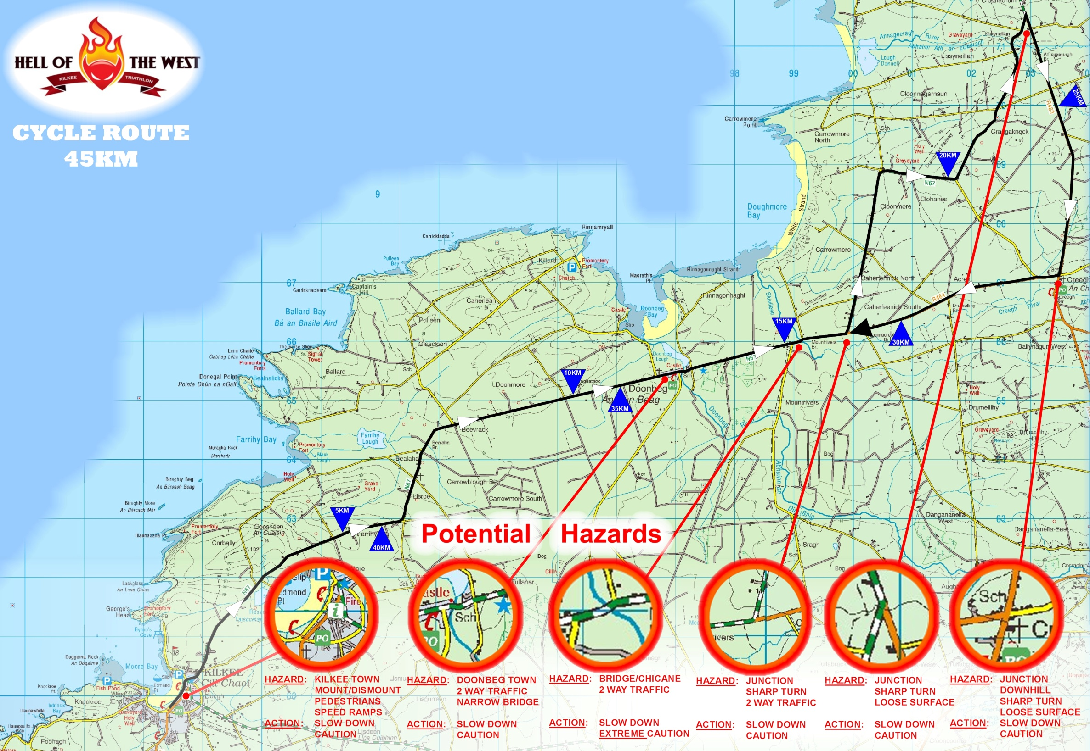



**Saturday June 27th 2009**

**1.5 km Swim 45 km Cycle 10km Run**

**TRANSITION 2**

Be careful on your return into T2. The area will be well marshalled – please listen to the marshals they are there to ensure your safety.

**THE FOLLOWING RULES APPLY IN T2.**

1. Dismount before entering the Transition area. You **must** place your bike on the rack before unfastening your helmet.

2. You must place bike on rack corresponding to your number.

3. Race number must be worn on the front during the run.



**Saturday June 27th 2009**

**1.5 km Swim 45 km Cycle 10km Run**

**RUN ROUTE**

The Dunlicky Road 10K run is a beautifully scenic out and back course overlooking the cliff faces of Kilkee. It’s also a tough run, with the hills over the first 5K a certain challenge for all levels of athlete. The good news is that the last 5K are mainly down hill and has fantastic views overlooking the Atlantic.

**RUN COURSE & POST RACE INFO**

* Exit right out of transition and run along the prom till you meet marshals directing you up the “Dunlicky Road/Hill”

* The Water station will provide hydration at 3.5km and 6.5km

* Timing mat will be located at turnaround – You must fully go round the turnaround, anyone not fully going round the turning point will be disqualified, unless the mistake is rectified by going back.

* Please cross the finish line in a controlled and safe manner, sprinting across the line, while dramatic, can be dangerous and can risk injury to marshals.
* Please remove your timing chip before leaving the finish area. We will have marshals in position to assist with this.
* Liquid refreshments and fruit will be available to all athletes at the finish line.
* Don’t forget to avail of the post –race recovery facilities. Please note however, that post-race facilities will not open until the first individual athlete has crossed the finish line.

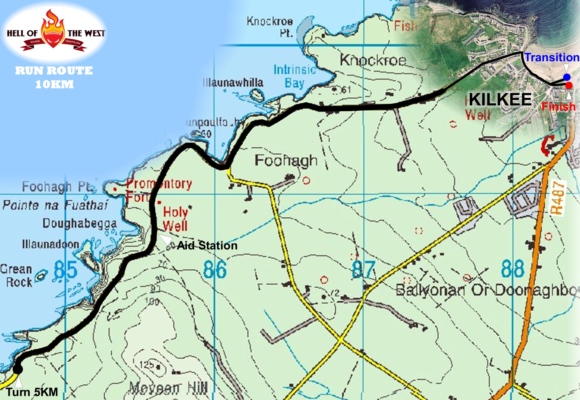



**Saturday June 27th 2009**

**1.5 km Swim 45 km Cycle 10km Run**

**POST RACE**

**DON’T FORGET TO ENJOY THE RACE!**

And if that’s asking too much you can start relaxing after the event at the race HQ in the Kilkee Bay Hotel.

**POST RACE FOOD**

Mealswill be served in the hotel from 2.30pm. Friends and family can of course join you for food and drinks in the hotel.

**PRIZE GIVING**

The Prize Giving ceremonyis scheduled to take place in the hotel at 5 pm. Provisional results will be issued after the prize giving. This part of the day is a time to relax and have fun whilst acknowledging the great achievements of all entrants. The craic defines Kilkee’s Hell of the West with lots going on besides the analysis of shaving seconds off your time.

Our evening entertainment kicks off from 8.30pm till late. For many this is the real endurance event of the day. Make sure you join the fun – You will have earned it! Yet again for the 32nd year we wish to thank you for your brilliant support, and may we wish you a very successful, enjoyable and safe race.